



Trunk or Treat
HALLOWEEN PARTY
Thursday, October 23
6:30-7:30pm
Rebecca S. Breed Clubhouse @ 4 Horseneck Lane
*There will be no evening programs*

The Club will CLOSE at 5:30pm so members can go home to get dressed for the SPOOKY & FUN event.

The front pick-up loop & parking garage will be CLOSED at 4:00pm on this day. ALL parents/guardians must park across the street and walk to the Club to pick up their child(ren).

Members must be dressed in costume and will go trick or treating with their parents

Apples, apple cider & music
Halloween Bags donated by the Greenwich Police Silver Shield Association


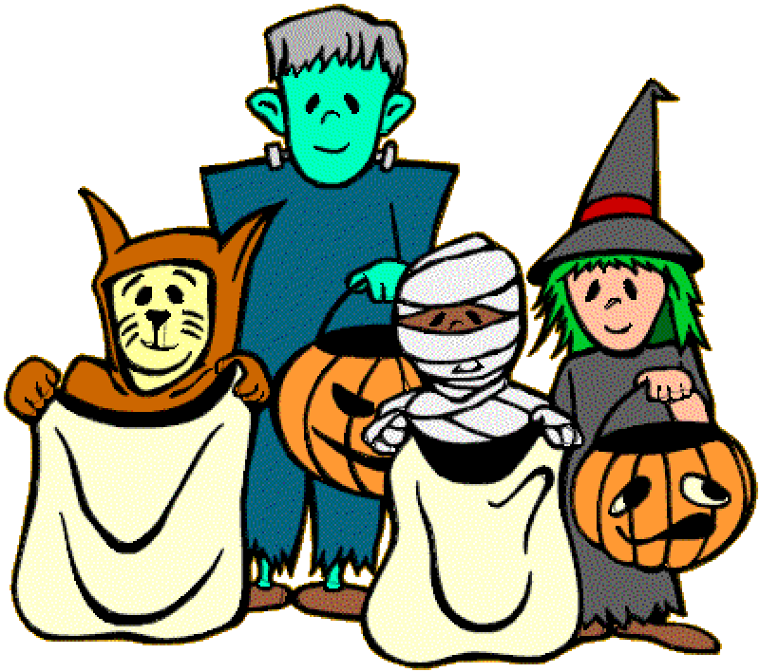
Safe – Friends – Your Club & Scary FUN!

For more information, contact the Boys & Girls Club
at (203) 869-3224

